*Zach Warren*

*Homework 2*

*ASTR 3800*

*February 23, 2016*

**import** numpy **as** np  
**import** matplotlib.pyplot **as** plt  
**import** pandas **as** pd  
**import** matplotlib.cbook **as** cbook  
**import** math  
  
Location = **r'C:\Users\Zachary Warren\OneDrive\S2 2015-2016\ASTR 3800\Homework2\src\SDSS_DR7.dat'**df = pd.read_csv(Location, delimiter = **' '**, names = [**'RA'**, **'Declination'**, **'z'**, **'Mg'**, **'Mr'**], skipinitialspace = **True**)  
  
f, plts = plt.subplots(3,2,figsize=(23,15))  
  
*#part 1*df.plot(kind=**'scatter'**, x=**'RA'**,y=**'Declination'**, ax=plts[0,0])  
  
df.plot(kind=**'scatter'**, x=**'z'**,y=**'Mr'**, ax=plts[0,1])  
plts[0,1].invert_yaxis()  
plts[0,1].set_xlim([0.0,.55])  
  
*#part 2*df[**'Mg-Mr'**] = df[**'Mg'**] - df[**'Mr'**]  
  
df[**'Mg-Mr'**].plot(kind=**'hist'**,ax=plts[1,0], bins=1200)  
  
plts[1,0].set_xlim([0.0, 1.5])  
  
*#calculate fraction***def** countNums(row):  
 **if** row[**'Mg-Mr'**] >= .75:  
 **return** 1  
 **if** row[**'Mg-Mr'**] < .75:  
 **return** 0  
  
df[**'>.75'**] = df.apply(**lambda** row: countNums(row), axis=1)  
  
totalBlue = df[**'>.75'**].sum()  
totalRows = len(df.axes[0])  
blueFraction = totalBlue/totalRows  
  
print(**'Total blue: '**, totalBlue)  
print(**'Total galaxies:'**, totalRows)  
print(**'Blue Fraction: '**, blueFraction)  
  
*#part 3***def** log(row,col,logVol):  
 **if** row[col] == 0:  
 **return** -logVol  
 **else**:  
 **return** np.log10(row[col]) -logVol  
  
**def** rBand(df,col,bin,logR,logVal):  
 bins = np.arange(df[col].min(),df[col].max(), .1)  
 df[bin] = pd.cut(df[col], bins)  
 group = df[col].groupby(df[bin])  
 groupSize = group.size()  
 gd = pd.DataFrame(groupSize)  
 gd[**'magAv'**]=df[col].groupby(df[bin]).mean()  
 gd=gd.reset_index()  
  
 gd[logR]=gd.apply(**lambda** row: log(row,1,logVal),axis=1)  
  
 gd=gd.dropna()  
  
 **return** gd  
  
  
gd=rBand(df,**'Mr'**,**'binnedMr'**,**'log'**,6.31)  
gd.plot(x=**'magAv'**, y=**'log'**, ax=plts[1,1])  
  
  
*#part 4***def** findGalaxies(row,mag,z):  
 **if** row[**'z'**] < z **and** row[**'Mr'**] < mag:  
 **return** 1  
  
**def** volume(z):  
 d = (3*math.pow(10,3)*z)  
 volume = (2.295/3.0)*math.pi*math.pow(d,3)  
 **return** volume  
  
**def** countBlues(row, sample):  
 **if** (row[sample] ==1):  
 **if** row[**'Mg-Mr'**] >= .75:  
 **return** 1  
 **if** row[**'Mg-Mr'**] < .75:  
 **return** 0  
  
  
*#volume sample 1  
#Mr <-20, z <.171*df[**'VSamp(-20)'**] = df.apply(**lambda** row: findGalaxies(row,-20,.171), axis= 1)  
total20 = df[**'VSamp(-20)'**].sum()  
df[**'VSamp(-20)Vals'**]=df[**'Mr'**].loc[df[**'VSamp(-20)'**] == 1]  
  
df[**'>.75(-20)'**] = df.apply(**lambda** row: countBlues(row, **'VSamp(-20)'**), axis=1)  
total20Blue = df[**'>.75(-20)'**].sum()  
  
vol20=volume(.171)  
logVol20=np.log10(vol20)  
  
d20=rBand(df,**'VSamp(-20)Vals'**,**'binned20'**,**'log20'**,logVol20)  
d20.plot(x=**'magAv'**,y=**'log20'**,ax=plts[2,0])  
  
print(**'V Sample One:'**)  
print(**'Redshift Bound: '**, .171)  
print(**'Total Galaxies: '**, total20)  
print(**'Total Volume: '**, vol20, **'h-3 Mpc3'**)  
print(**'Blue Galaxy Fraction: '**, total20Blue/total20, **'\n'**)  
  
*#volume sample 2  
#Mr <-19, z < .108*df[**'VSamp(-19)'**] = df.apply(**lambda** row: findGalaxies(row,-19,.108), axis= 1)  
total19 = df[**'VSamp(-19)'**].sum()  
df[**'VSamp(-19)Vals'**]=df[**'Mr'**].loc[df[**'VSamp(-19)'**] == 1]  
  
df[**'>.75(-19)'**] = df.apply(**lambda** row: countBlues(row, **'VSamp(-19)'**), axis=1)  
total19Blue = df[**'>.75(-19)'**].sum()  
  
vol19=volume(.108)  
logVol19=np.log10(vol19)  
  
d19=rBand(df,**'VSamp(-19)Vals'**,**'binned19'**,**'log19'**,logVol19)  
d19.plot(x=**'magAv'**,y=**'log19'**,ax=plts[2,0],color=**'g'**)  
  
print(**'V Sample Two:'**)  
print(**'Redshift Bound: '**, .108)  
print(**'Total Galaxies: '**, total19)  
print(**'Total Volume: '**, volume(.108), **'h-3 Mpc3'**)  
print(**'Blue Galaxy Fraction: '**, total19Blue/total19, **'\n'**)  
  
*#volume sample 3  
#Mr < -18 z <.068*df[**'VSamp(-18)'**] = df.apply(**lambda** row: findGalaxies(row,-18,.068), axis= 1)  
total18 = df[**'VSamp(-18)'**].sum()  
df[**'VSamp(-18)Vals'**]=df[**'Mr'**].loc[df[**'VSamp(-18)'**] == 1]  
  
df[**'>.75(-18)'**] = df.apply(**lambda** row: countBlues(row, **'VSamp(-18)'**), axis=1)  
total18Blue = df[**'>.75(-18)'**].sum()  
  
vol18=volume(.068)  
logVol18=np.log10(vol18)  
  
d18=rBand(df,**'VSamp(-18)Vals'**,**'binned18'**,**'log18'**,logVol18)  
d18.plot(x=**'magAv'**,y=**'log18'**,ax=plts[2,0], color=**'r'**)  
  
print(**'V Sample Three:'**)  
print(**'Redshift Bound: '**, .068)  
print(**'Total Galaxies: '**, total18)  
print(**'Total Volume: '**, volume(.068), **'h-3 Mpc3'**)  
print(**'Blue Galaxy Fraction: '**, total18Blue/total18, **'\n'**)  
  
  
*#part 5***def** z(mag):  
 **if** mag == **None**:  
 **return** .1  
 **else**:  
 **return** math.pow(10,((mag-17.77)/(-5) -9.322))  
  
**def** log2(row,col,z):  
 **if** row[col] == 0:  
 **return** -np.log10(volume(z))  
 **else**:  
 **return** np.log10(row[col]) -np.log10(volume(z))  
  
**def** rBand2(df,col,bin,logR):  
 bins = np.arange(df[col].min(),df[col].max(), .1)  
 df[bin] = pd.cut(df[col], bins)  
 group = df[col].groupby(df[bin])  
 groupSize = group.size()  
 gd = pd.DataFrame(groupSize)  
 gd[**'magAv'**]=df[col].groupby(df[bin]).mean()  
 gd=gd.reset_index()  
  
 gd[**'MagMr'**] = gd.apply(**lambda** row: z(row[**'magAv'**]), axis=1)  
 gd[logR]=gd.apply(**lambda** row: log2(row,1,row[**'MagMr'**]),axis=1)  
  
 gd=gd.dropna()  
  
 **return** gd  
  
gMax=rBand2(df,**'Mr'**,**'binnedMr'**,**'logMax'**)  
gMax.plot(x=**'magAv'**, y=**'logMax'**, ax=plts[2,1])  
  
  
  
*#Titles and Axes labels*plts[0,0].set_title(**'Declination vs RA'**)  
  
plts[0,1].set_title(**'Mr vs z'**)  
  
plts[1,0].set_xlabel(**'(g-r)'**)  
plts[1,0].set_title(**'(g-r) Color Distribution'**)  
  
plts[1,1].set_xlabel(**'Mr'**)  
plts[1,1].set_ylabel(**'log(dn/dMr)'**)  
plts[1,1].set_title(**'r-band Luminosity'**)  
  
plts[2,0].set_xlabel(**'Mr'**)  
plts[2,0].set_ylabel(**'log(dn/dMr)'**)  
plts[2,0].set_title(**'r-band Luminosity for Vol Lim Samples'**)  
  
plts[2,1].set_xlabel(**'Mr'**)  
plts[2,1].set_ylabel(**'log(dn/dMr)'**)  
plts[2,1].set_title(**'r-band Luminosity with 1/Vmax Weight'**)  
  
plt.show()

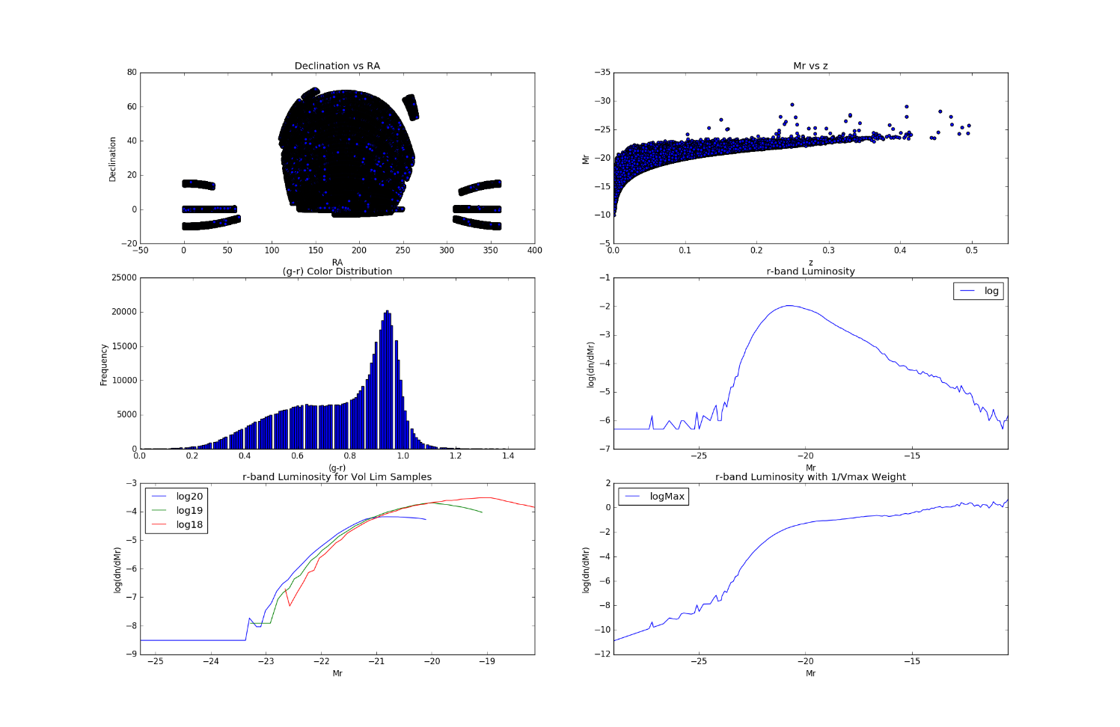

Output from program:

Total blue: 328989

Total galaxies: 550166

Blue Fraction: 0.5979813365420619

V Sample One:

Redshift Bound: 0.171

Total Galaxies: 307242.0

Total Volume: 324461673.0042967 h-3 Mpc3

Blue Galaxy Fraction: 0.6774008761822928

V Sample Two:

Redshift Bound: 0.108

Total Galaxies: 257626.0

Total Volume: 81742203.0837476 h-3 Mpc3

Blue Galaxy Fraction: 0.590258747176139

V Sample Three:

Redshift Bound: 0.068

Total Galaxies: 128634.0

Total Volume: 20403365.531192 h-3 Mpc3

Blue Galaxy Fraction: 0.4873128410840058

The luminosity functions made from all of the volume limited samples show more accurately the amount of galaxies at lower luminosities. The flux limited sample shows more of the very luminous galaxies because we can see more of them, even though we know there should be more less luminous galaxies. The weighted sample does the same thing by adjusting the ‘amount’ of galaxies at far distances (the more luminous ones) and increasing the ‘amount’ of galaxies nearby, essentially increasing the number of low luminosity galaxies vs high luminosity galaxies.